San Diego Trail Alliance Agenda
Monday, October 16th, 2017
- Purpose:
    - Keep trails open for all recreational users.
    - Foster good communication between all recreational user groups.
    - Maximize use of recreational facilities for all.

The meeting was held at Denny’s, Lisa Wood taking notes. Denny’s was providing an opportunity to contribute to NO KID HUNGRY program. The waitress was a little choked up when she told me that Trails Alliance members participated in the program voluntarily to provide 270 meals for hungry children. CONGRATULATIONS! This emphasizes the main theme: just coming and participating has positive results. It is effort, but it is enjoyable, and worthwhile. Thank you SDTA!

- PLDO (Park Lands Dedication Ordinance) – Mark Kukuchek. The PLDO (Park Lands Dedication Ordinance) was adopted in 1973, pursuant to the State Quimby Act, Section 66477 of the Government Code, to meet the park and recreational needs of residents of new residential developments. The County of San Diego’s award-winning park system is considered key to the region’s health, safety and quality of life. A majority of the unincorporated County, in excess of 90 percent, is either open space or undeveloped. This includes several large federal, state, and regional parklands that encompass much of the eastern portion of the County. Only 35 percent or about 807,000 acres of the unincorporated County is privately owned.

Building and maintaining parks are among the County’s core responsibilities, along with roads and sewers. Developers must pay park fees per the County Code of Regulatory Ordinances, Title 8, Division 10, Chapter 1, Section 4: Section 810.103: “As a condition of approval of any development, the applicant shall dedicate land, pay fees in lieu thereof, or a combination of both . . . for neighborhood and community park or recreational purposes to serve future residents of such development.” For developments of 50+ parcels, the County typically requires dedication of land. For developments on less than 50 parcels, in-lieu fees may be accepted. The PLDO divides the County into 24 Local Park Planning Areas (LPPAs). Each LPPA requires different payments based on costs within the LPPA, current park acreage, and population density.
Policy F-29 states that it is the policy of the Board of Supervisors that, “fees received pursuant to the Park Lands Dedication Ordinance will be used for land acquisition and development of new, or rehabilitation of existing, County local park or recreational facilities or for such facilities when they occur in a regional park and are available to serve the recreational needs of local residents. PLDO funded projects will proceed only after capital, operations and maintenance funding is identified. Future PLDO projects will be included in the County’s Capital Improvements Needs Assessment (CINA) process.”

PLDO cannot fund property purchase, or for operations and maintenance. As currently defined, trails are “passive” uses, not eligible for PLDO funds. “Active Recreational Uses” means recreation facilities occurring on level or gently sloping land (maximum 10%) restricted for park and recreation purposes in a planned development . . . designed to provide individual or group activities of an active nature common to local parks in San Diego County, including, but not limited to, open lawn, sports fields, court games, swimming pools, children's play areas, picnic areas, recreation buildings, dance slabs, and recreational community gardening. Active Recreational Uses do not include natural open space, nature study areas, open space for buffer areas, steep slopes, golf courses, riding and hiking trails, scenic overlooks, water courses, drainage areas, water bodies (lakes, ponds, reservoirs), marinas and boating areas, parking areas, and archaeology areas.

In 2015, the Board of Supervisors approved research possible changes to the PLDO. “To build on our success, we must look at policy and financial to work toward stripping away barriers that make it tougher to develop new parks and facilities in our communities.” In 2016, the Board directed the Department of Parks and Recreation (DPR) to conduct a comprehensive PLDO update. It provided funding for a consultant study of the legal basis of the PLDO: Quimby Act, Mitigation Fee Act, or both. The study examines the feasibility of requiring projects that only pay in-lieu fees to fund ongoing maintenance; realigns the Local Park Planning Areas to coincide with the Community and Subregional Plan Area boundaries; and examines broadening the scope of the County’s park fee program. DPR is to return to the Board of Supervisors to request adoption of a new ordinance by summer 2018. All changes to the PLDO will align with the County’s Parks Master Plan. Marcus Lubich is the project manager can be reached at (858) 966-1348 or marcus.lubich@sdcounty.ca.gov.

Mark Kukuchek has been participating in this process. He says positive changes will be made, although the Building Industry Association is pushing for as much park “credit” for other land-eating responsibilities, including protection of steep slopes and provision of storm water detention areas. A compromise providing partial credit for these areas will be made. Developers, generally would rather give money than land.

The PLDO definitions also touch the Multiple Species Conservation Program. The MSCP allows passive uses, but does not allow active uses. So trails need to be “active” for funding purposes of the PLDO, but “passive” to be allowed within the MSCP. The MSCP: preserves unique, native habitats and wildlife; works across political boundaries; protects watersheds; streamlines permitting; ensures compliance with the federal and state Endangered Species Acts and Natural Communities Conservation Planning Act. Species can be listed as rare and endangered by U.S. Fish and Wildlife Service law and/or by California Department of Fish and Wildlife (Wildlife Agencies). The MSCP allows for larger scale planning, instead of property by property. The San Diego County Board of Supervisors approved the County Subarea Plan on October 22, 1997. The boundaries of the County Subarea Plan apply to land that is served by the City of San Diego Metro Wastewater Sewer System: from the southern portion of Ramona and the San Dieguito River, east to Poway, Lakeside and Alpine, and south to the border with Mexico. The County is currently working on a plan for the northern part of the unincorporated area (North County Plan) that extends from the area around the incorporated cities of Oceanside, Encinitas, San Marcos, Vista, and Escondido east to the Cleveland National Forest and north to Riverside. Essential facilities including parks can be sited within MSCP land provided: a) The project is consistent with the County General Plan, the MSCP and Subarea Plan; b) All feasible mitigation measures have been incorporated, and there are no feasible, less environmentally damaging alternatives that would meet project objectives; c) Where a project impacts a wetland or floodplain, mitigation measures result in a net gain; d) Where a project impacts steep slopes, revegetation is native; e) No mature riparian woodland is destroyed or reduced in size; and f) All critical populations of sensitive species are avoided per the Subarea Plan. ACTION NEEDED: Mark to continue participating in PLDO. MSCP should also be monitored.
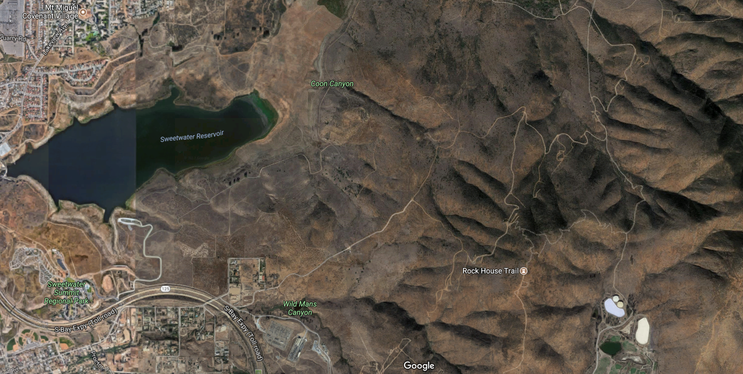

3. Sweetwater Reservoir Riding & Hiking Trail. Mark Kukuchek also discussed the status of trails in the reservoir area – the loop trail and the truck track. The Sweetwater Reservoir Riding and Hiking Trail is a County of San Diego trail, operated through an easement granted by Sweetwater Authority. The trail is nearly five miles long and runs along the south side of Sweetwater Reservoir. The trail entrance is at Sweetwater Regional Park off of San Miguel Road in Bonita. http://www.sdparks.org/content/sdparks/en/park-pages/SweetwaterSummit.html Pedestrians, bicycles, horses and pets are allowed on the trail. No rest rooms or drinking facilities are available on the trail.

The truck track is through an area with vernal pools that the wildlife agencies want to close now that the Reservoir Loop Trail is open. Horses are not to be allowed on the loop trail because of concerns about E. coli (bacteria) from manure running off into the drinking water reservoir. Apparently Supervisor Cox got some FEMA money to repair a river bottom trail washout. There is an alternative trail via an SDG&E easement. The General Manager is General Manager Tish Berge 619-420-1413. ACTION NEEDED: Bonita Valley Horsemen are participating.
4. Land Use Passes. Mark Kukuchek also said that he California Department of Fish and Wildlife (CDFW) is expanding its Lands Pass Program to include 43 (of 247) wildlife areas and ecological reserves (https://nrm.dfg.ca.gov/FileHandler.ashx?DocumentID=149824&inline). CDFW manages more than 1 million acres of land. Most of the funding to manage them comes from hunters and anglers. The State Legislature directed CDFW to develop more income. In August 2016, after a lengthy public review process, the Fish and Game Commission voted to add 37 more properties to the visitor pass requirement. Each visitor 16 years of age or older must carry a pass, unless they are carrying their own valid California hunting or fishing license. School and organized youth groups (including accompanying adults), are also exempt. https://www.wildlife.ca.gov/licensing/lands-pass Daily pass $4.32; annual pass $24.33. If you purchase an annual lands pass after the first of the year, it is valid for the remainder of that year. Tracy Nelson and Julie.Horenstein@wildlife.ca.gov are contacts. Properties affected include: Batiquitos Lagoon, Boden Canyon, Hollenbeck Canyon, and San Elijo Lagoon. ACTIONS NEEDED: Purchase pass if going to one of these areas.

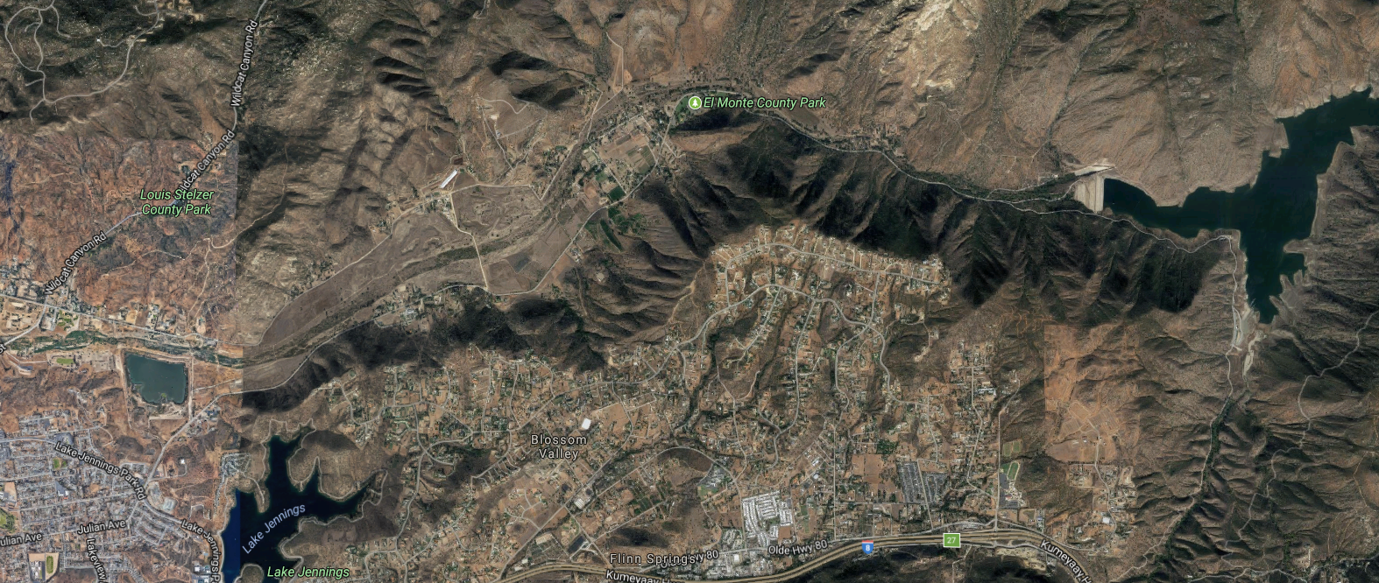

5. El Monte Update. Lisa Wood (from Lakeside Frontier Riders) continues to monitor the proposed sand mine in El Monte Valley, Lakeside. This large valley is a key component of the DESIGNATED county trail system. However, none of the trail through the valley is DEDICATED. In other words, it is on the map, but the land is privately held, with few, if any, easements. Item 9, below, talks about the benefit of having a place where mountain bikers can go fast and not endanger horses (Orosco Ridge). El Monte Valley is well suited to nice long, safe canters on horseback. A rare treat not to worry about pedestrians or bicycles (they do not prefer the sandier substrate of El Monte). Sand miners have purchased much of the valley from Helix Water District, and will be producing an Environmental Impact Report (EIR) sometime in the near future describing a proposed sand mine. It is anticipated that there will be trails proposed, but that they will be unappealing trails sandwiched between the roadway and sand mine. There is an existing County equestrian staging area at El Monte Park. The sand mine would occur over several hundred acres to the west of the staging area. Lisa’s group has raised enough money to have the attorneys for the Cleveland National Forest Foundation review the EIR and provide recommendations, when it comes out. ACTIONS NEEDED: Lisa to continue monitoring. Consider sending a letter to a Board of Supervisor’s member about the value of El Monte Valley trails. Margaret Diss (County Parks) to tackle the significant GIS work needed to provide public maps of designated trails/parks (2 year timeframe).
6. Lakeside Downs. Lisa Wood continues to monitor. This preserve is located west of State Route 67 (SR 67) in the Lakeside area, just outside of Santee’s conservation boundaries and about three miles from Marine Corps Air Station (MCAS) Miramar. The property supports California gnatcatcher and spiny redberry. Michael Beck, executive officer at the Endangered Habitats Conservancy said the area will be closed to the public for biological reasons and fire danger. He hopes for the return of the Hermes copper butterfly. Helix Land Ltd sold 410 acres, with the Department of Defense chipping in half of the $8 million, to help prevent encroachment into the base’s area of influence via its Readiness and Environmental Protection Integration (REPI) Program. SANDAG chipped in the other $4 million using TransNet Environmental Mitigation Program funds, which comes from a half-cent sales tax for transportation approved by voters in 2004. It is partly this use of TransNet money that makes the closure of the site to the public particularly concerning. ACTIONS NEEDED: Lisa to monitor. If people want to fight for access, contacting SDG&E about the utility easement might be the best approach.

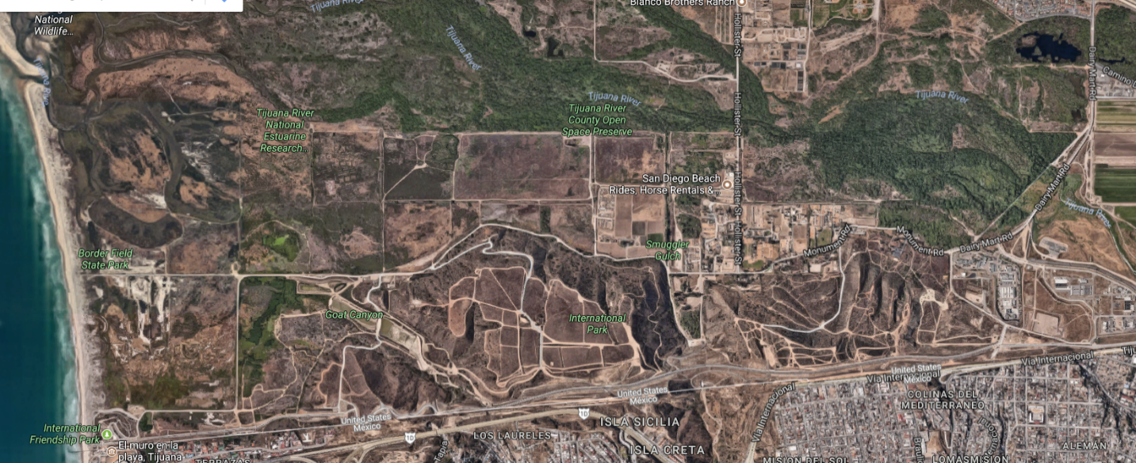
7. Tijuana River Valley. Emma Reese (from Tijuana River Valley Equestrian Association) says that a horse campground will not occur – insufficient funds ($1.7 million).
During the September TRVEA cleanup, they couldn’t get into Goat Canyon because of high E. coli (bacteria) levels.
The City is proceeding with dredging to prevent upstream flooding.
Emma lamented the loss of access to Spooners Mesa. Before the border wall went up, you could ride from mesa to mesa, but now the access is cut off, and what is left has slippery rocks on it.
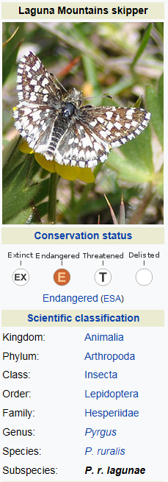
Regarding the issues that have been worked on between mountain bikers and equestrians in this area, she said that bells are being put out and promptly stolen. She has not heard any bell use in the area since the program started.
Emma and Margaret Diss (County Park and Recreation) discussed the wildlife camera. The County would like an accurate count of equestrians, so the location of the camera may need to be changed.
ACTION NEEDED: Emma to follow up with Margaret regarding camera location.

8. Mount Laguna Draft Plan. Ben Stone from SDMBA provided an update on Mt Laguna. Asked equestrians about their use of Wooded Hill, Penny Pines. Talked about a reroute at the end of Gatos. Explained that federal standards make installing bridges difficult. Discussed the need for archeological surveys. Lindsey is the recreation ranger, and she is dealing with the fact that meadow trails are in Laguna Mountain skipper habitat. Legally you can walk anywhere (not ride or bike) and trails go through habitat. This is an opportunity to get 12 – 16 miles of additional trails by rerouting trails to better location. This work will assist with discouraging use of butterfly habitat. There continues to be increasing demand for trails and recreational users of limited open spaces. Increased development is likely to occur in this area as a result of an expired citizens’ initiative, which will allow more residential development in the area, resulting in even more demand for trails.
http://www.sandiegouniontribune.com/news/environment/sd-me-zoning-lawsuit-20170113-story.html
Given this situation (likely increased development) more trails, to spread out the increased users, are needed. Lots of new single track trail, better to ride on bike and horse than what is there now, would be provided under this plan. Volunteers to help with trail work will be needed. The part in CNF with Cuyamaca planning should be pretty speedy. Need to work aggressively to get it into the Forest Plan. However, ultimately, what is needed is a leg through Anza Borrego, but that will be very slow going.
ACTION NEEDED: SDMBA to continue working on trails issues in this area; will notify the Alliance when assistance is needed.

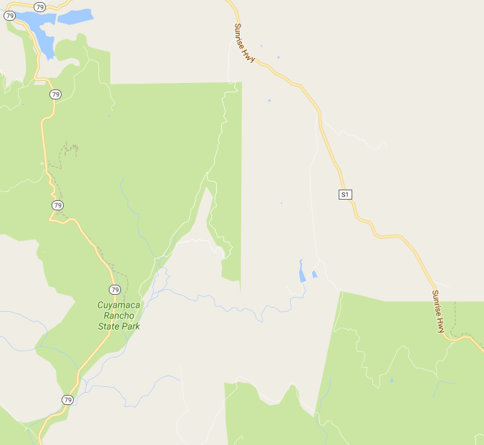

9. Anderson Truck Trail. Ben reports that SDMBA has worked with the County to prioritize acquiring a property that will help with trails planning in this area. There are some tribal lands that cannot be touched – they are the Indians that were flooded out by the City of San Diego when El Cap reservoir was installed. However, outside of the tribal area there are trails potential, especially by narrowing-up existing dirt roads. This area will require effort. SDMBA has dedicated people who show up, take necessary classes such as ArcGIS, work, and donate. ACTION NEEDED: SDMBA to continue coordination on this and will notify Alliance when assistance is needed.

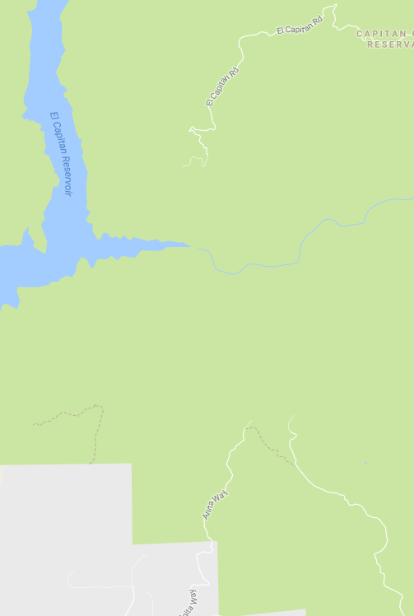
10. Orosco Ridge/Pamo Valley. Ben says 80 miles of trails envisioned, but will focus first on 20 miles. SDMBA’s plan for this area is World Class Mountain Bike destination. Trails Solutions will provide the concept for 80 miles of trail, some mountain bike-only, some mixed use, on 23,000 acres, with different levels of trail. Working with chamber of commerce, Romana Trails Association, had 65 people at a meeting, encouraged about bringing $ to Ramona. Cleveland National Forest is very supportive – William Metz, Forest Supervisor (858) 673-6180. SDMBA has raised $53,000 for environmental review, will need $120,000 for phase I and $500,000+ for phase II. The first 20 miles will be in the south west area where there has been a lot of fire, and there is selenium and lead contamination from shooting. Lots of ORV use now in the area. Quite disturbed. This will be for mountain bikes only, but it will benefit equestrians on other trails by providing a place where bicycles can go fast downhill, which they cannot safely do on multi use trials. No staging area is proposed with the first 20 miles of trails. Trails will be 2-3 feet wide, max. The first 20 miles will be “flow trails” – one direction, with 5-6% grade. Hoping for County grants to help with construction costs. ACTION NEEDED: SDMBA will be asking for support.

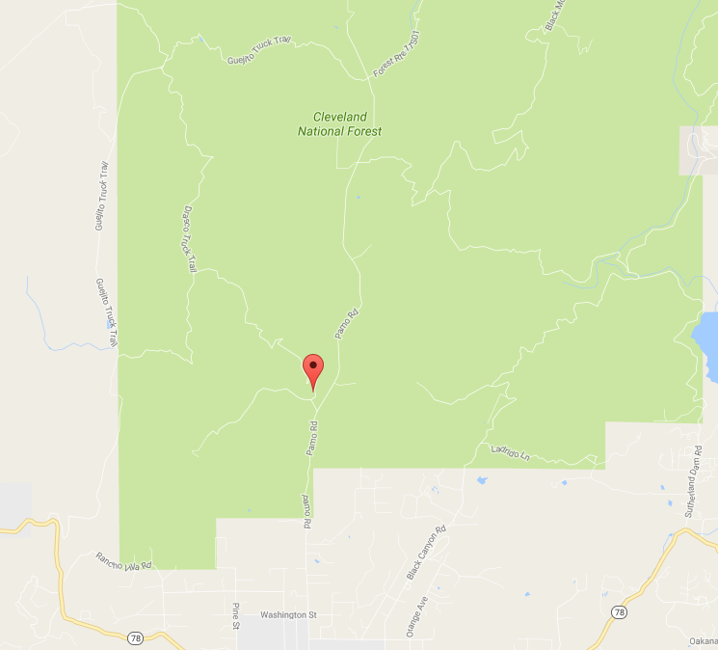

11. Grasslands/Old Survey Road 97 (Ramona Area). Glen Morgan and Don Wendt of Ramona Trails Association have been providing docent-led rides through 6 miles of multiuse trails in the County Grasslands Open Space Preserve, formerly the Guildred property (Montecito Ranch), on the historic Kit Carson / Kearney Road. Groups are very small. The docent-led rides are available in the non-breeding season for the eagles. Every other week the guides provide hikes, and the alternating weeks are for equestrians, but it hasn’t been very full. Please come: using the docent program shows interest, and encourages funding. Glen leading a ride November 11 at 9:00. Staging area on Highland Valley Rd., just east of Archie Moore Rd. Southwest of Ramona, west of State Route 67, north of Highland Rd. and east and west of Rangeland Rd. The Ramona Grasslands Preserve is located in the Santa Maria Valley. The Preserve consists of 3,521 acres. Currently, a 480-acre western portion has the trails. The County of San Diego Department of Parks and Recreation is currently managing the Preserve for its biological resources, such as the Stephen’s kangaroo rat (and ticks), consistent with the management strategies of the Draft North County Multiple Species Conservation Program. The County of San Diego Department of Parks and Recreation is committed to providing passive recreation opportunities within the Preserve that further the development of the Coast to Crest Trail. However, Ramona Grasslands East (the Ole Rodeo Grounds) has been locked down by the wildlife agencies, making the staging area there unavailable. Access denied at the staging area for the Grasslands at Rangeland Road. ACTION NEEDED: Consider a ride here, to show continued interest.

- 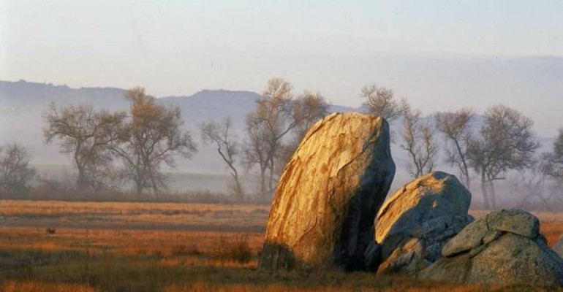

12. Boulder Oaks (Ramona – off Mussey Grade Road). Located approx. 3 miles south of Ramona between State Route 67 and Mussey Grade Road (760) 788-3326, has 6.81 miles of existing trails. 9.00 miles are proposed, and 7.69 will be closed, resulting in 8.12 miles of trails, an increase of 1.31 miles. There will be three staging areas, one of which will be equestrian-only. Boulder Oaks Preserve is a good riding location, consisting of 1,268 acres of meadows and hills, just south of Ramona and north of the San Vicente Reservoir – extending east from Iron Mountain and north of Fosters Canyon. San Diego County acquired the Preserve in 2003 for inclusion in the County of San Diego’s Multiple Species Conservation Program (MSCP) preserve system. The Preserve consists of natural vegetation communities including open coast live oak woodland, open Engelmann oak woodland, southern mixed chaparral, scrub oak chaparral, non-native grassland, southern willow scrub and freshwater marsh. ACTION NEEDED: Plans look good. Monitor.

- 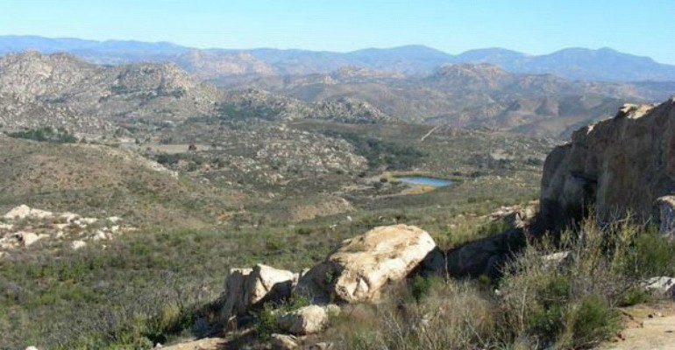

13. La Cañada de San Vicente (Ramona Area - San Vicente Road and Chuck Wagon Road). The Monte Vista Ranch covered most of what CDFW renamed as Canada de San Vicente. Monte Vista Ranch covered land South of Barnett Ranch (County Parks owned) to Barona Tribal land and San Vicente Reservoir (City of San Diego). The Johnson family regularly allowed Ramona Trails Association and other groups to use Monte Vista Ranch roads for Poker Rides and outdoor activities. In 2006 the State refused to purchase the Monte Vista property without the buildings, pool and conference center as the Johnson family wanted to retain them as an educational center for school children. The State has not created an outdoor learning center; however they have a nice retreat and offices for CDFW staff. After the Monte Vista Ranch, CDFW out maneuvered San Diego County parks in buying the Spitzburgan property in 2008. The County intended making a critical link between the Luelf Pond Trail and the Barnett Ranch trails across the Spitzburgan 400 acres, crossing Davney creek which flows to San Vicente Reservoir. Incidentally, the trail between Luelf Pond and Barnett is on old Coast and Geodetic maps as "native." It was a foot path between San Pasqual and the village near San Diego Country Estates. The State Purchase was thought to be a good thing (hoping to connect Barnett with Holly Oaks and Luelf Pond trails). Unfortunately, CDFW put up signs and fences for no trespassing. Ramona Trails invited the new State Property manager, Jason Price, to a 2008 meeting. Jason warned against trespassing.

In 2010 RTA and The Holly Oaks Association(HORCI) negotiated extensively with Jason and State Lawyers and had a three-page agreement to open the 1/4 mile of trail (on a dirt access road) to connect the County Luelf Pond trail to the County, Southern Oak Road Pathway to allow that loop to connect. Sacramento asked RTA and HORCI to indemnify the State of California for that portion of their property. Dianne Jacobs and San Diego County offered to indemnify the State, however, the State refused, insisting it had to be RTA and HORCI. CDFW even refused a request to tour the property by State Assemblyman Brian Jones in 2013, and State Senator Joel Anderson in 2017. After one of Dianne Jacob's trails meetings, Ed Pert, the Regional CDFW director said he was very willing to work on what he called the Northwest triangle of the Canada de San Vicente property to complete the ¼-mile loop. Ed has not responded to question.

The California Department of Fish and Wildlife (CDFW) and the California Department of Parks and Recreation (CDPR) have prepared and adopted a Mitigated Negative Declaration (MND) for the Cañada De San Vicente Ecological Reserve Land Management Plan. Volume 1: Final Land Management Plan (PDF); Volume 2: Final Initial Study/Mitigated Negative Declaration (PDF). The purpose of the Plan is to serve as a descriptive inventory of fish, wildlife, plants, and habitat types which occur on the Reserve. The primary use of the Reserve will be as protected open space and wildlife habitat, with possible public uses to include hunting, education, and scientific research. Management will focus on maintaining viable populations of sensitive species and their habitats, and on the restoration and enhancement of natural communities within an ecosystem-based framework. Emphasis will be placed on the protection of riparian and wetland areas, restoration and enhancement of native grassland, and the control of noxious weeds. ACTION NEEDED: If people want to ride here, they will have to work with these agencies.

14. Other Ramona Connection Challenges: The Santa Maria Greenway through Ramona and connection with the Coast to Crest Trail and the Park to Pines trail, opening Forest Service gates blocking the Coast to Crest trail along the Lower Santa Ysabel Truck Trail.

15. Del Mar Area Trails. Julie Klein (SDTA). The City of Del Mar and San Dieguito Lagoon are at the west end of the envisioned 55-mile Coast to Crest park system overseen by the San Dieguito River Valley JPA, but the City of San Diego boundaries cover much of the area to the east of the actual coastline. Farther east yet, along this river, is unincorporated area. Shawna Anderson is the environmental planner for the JPA. The west end has connection issues – currently there is no connection to the beach, and riding on the beach itself, a short 1/4 miles strip that allows off-leash dogs, is endangered because of a recent dog v horse incident. The only way to access the beach is to stage off the road in the early morning. Meeting October 18 to discuss beach access. On easement and access areas farther east, Casey Smith, the City of San Diego Deputy Director for Open Space, is working with Julie on a cross walk and to address a sink hole. Julie has investigated and found that while there are nearly 300 horses in her area, there are only about 5 trail riders. ACTION NEEDED: Julie to continue to participate.

16. National Legislation. Marty Jorgensen (Backcountry Horsemen) reminded us that HR 1349 would amend the federal Wilderness Act to allow wheeled vehicles (including bicycles, wheelchairs and strollers) in wilderness areas. Supported by the Sustainable Trails Coalition (a mountain bike group), not supported by BCHA, IMBA (another mountain bike group), and a large coalition of trail and wilderness users. Local representative Duncan Hunter is currently supporting this bill. Senator Duncan Hunter, 2429 Rayburn House Office Building, Washington D.C. 20515. ACTION NEEDED: Consider sending Duncan a letter asking the legislation be rejected.

17. Boulder Oaks – off Interstate 8. Boulder Oaks is the only equestrian site on the Descanso district of CNF, it provides 17 horse corrals, 30 camp sites, and local access to the Pacific Crest Trail. The Descanso district of the Cleveland National Forest is in the final planning stages of renovating the campground. The revision will include new restrooms, tables, fire rings and redesign of the pull-through parking areas in the equestrian camping area. ACTION NEEDED: BCHC-SD is working with them to insure the needs of the equestrian community are met.

18. Indian Flats – Warner Springs area. The addition of horse camping facilities at this campground have been put on hold due to closure of the campground due to water issues. ACTION NEEDED: BCHC-SD will continue to work with the Palomar District on the design of the sites.

19. Cuyamaca/ Anza Borrego State Parks. BCHC-SD public lands representative Terry Jorgensen has been in discussion with the current managers and has been assured that recently enacted regulations concerning natural and cultural reserves within the parks will not affect trail use.

20. Memorial Benches. The memorial benches being proposed at Granite Springs Trail Camp for Garry McClintock and Bernie Martin have been denied by State Parks because they do not meet the criteria needed to be memorialized within the park. ACTION NEEDED: Cindy McKeivick and Marty Jorgensen will continue to work on other options.

21. Event Announcements.

* Trail Stewardship Summit. November 2-5. Susie Murphy of SDMBA reminded the group of the San Diego Mountain Biking Association and the National Forest Service 2017 Trail Stewardship Summit November 2-5, 2017 in Lakeside at the community center. The summit will bring together federal, state, county, and city agencies with the goal of facilitating stronger partnerships. The Forest Service will bring professional trail building, maintenance, and education skills to this event. Marty lauded this opportunity and urged equestrians to attend trail training events. The purpose of this event is to engage community partners in trail operations and planning on the Cleveland National Forest, specifically the Palomar and Descanso Ranger Districts. This event consists of two sessions. Attendees are welcome to attend both sessions (all four days) or just one session (Th-F or Sat-Sun). The first two days will involve presentations by the U.S. Forest Service and partners. The second half will involve field training and certification of trail crew leaders for qualified individuals and general trail volunteers who want to increase their skills. For more information please email Susie Murphy at executivedirector@sdmba.com ACTION NEEDED: Encourage equestrian clubs to participate in trail building and trail training opportunities.

* Vern Whittaker. November 2-5. The San Diego Unit of Backcountry Horsemen of California will be holding their 25th annual Vern Whittaker Service Weekend Thursday November 2nd through Sunday November 5th. This event is at Vern Whittaker Horse Camp in Borrego Springs, Ca. and offers four days of camping for free in trade for one day of work on the Lower Willows Trail. All trail users are welcome- not just equestrians. For more information contact Terry at tlh9749@yahoo.com.

* Stagecoach. February 16-19. Stagecoach Trails RV Resort in Shelter Valley has begun taking reservations for the 2018 President's Day Campout. The campout will go from Thursday February 15th to Monday February 19th. For many years this has been a cooperative event between BCHC-San Diego Unit, Lakeside Frontier Riders, Pine Valley Mountain Riders, and the Ramona Trails Association. It's a fun event at a great venue, and as usual Lakeside Frontier Riders will be hosting Game Nights, Pot Lucks, and a Pancake Breakfast in the lodge. Lots of great riding is available right out of the resort in Anza-Borrego Desert State Park. Stagecoach Trails RV Resort can be contacted at frontdesk@stagecoachtrails.com or (760)765-3765.

22. SDTA Meeting Schedule for 2018. Mark your calendars!!
January 15, 2018
April 16, 2018
July 16, 2018
October 15, 2018

AT A GLANCE
Project Name | Site | Lead | Goal | Actions
REGULATORY
PLDO | County trails | Mark Kukuchek | Use developer funds for trails | Participate in meetings
HR 1349 | Federal wilderness areas | BCHM/Marty/all | Keep wilderness trails calm and safe | Consider sending letters to Congressional reps about trail values.
MSCP | County preserve areas | All | Keep trails through habitat. | Participate in MSCP development.
Land Use Passes | Wildlife agency properties. | All | Compliance with regulations. | Must purchase passes in these areas. https://www.wildlife.ca.gov/licensing/lands-pass
RAMONA
Ramona Grasslands | Highland Valley Rd | Glen Morgan/RTA | Open up more trails and staging. | Participate in meetings, go on/lead rides.
Boulder Oaks | Mussey Grade Road | RTA | Influence design. | Continue to monitor.
La Canada | San Vicente & Chuck Wagon Road | RTA/LFR | Open up trails and facilities. | Negotiate with wildlife agencies.
Santa Maria Greenway
Pamo Valley Master Plan | Orosco Ridge | SDMBA | World Class Mountain Biking destination. (Also multi-use trails; second phase.) | Fund raising, community support, participation and push.
LAKESIDE
El Monte Valley | Between El Monte Road and Willow Road | Lisa Wood | Save key trail linkage for mountains to coast system along the San Diego River from destruction by sand mine. | Participate in meetings; write letters to County Board of Supervisors about the value of the valley; monitor sand mine progress. Please consider sending a letter.
Lakeside Downs | West of State Route 67 | LFR? | Obtain use of SDG&E easement? | SDTA sent a letter to  Joshua Menvielle@sdcounty about this. Work with SDG&E will be needed to secure easement access. Point person needed.
Anderson Truck Trail | East of El Capitan Reservoir | SDMBA | Obtain trail access. | Negotiate with County and private property owners.
Flume Trail | El Monte Road | Lisa Wood | Trail recommendation | Celebrate this new trail.
DEL MAR
Beach Access | Highway 1 | Julie Klein | Resolve conflicts with dogs/pedestrians. | Participate in meetings.
Coast to Crest connections | San Dieguito Lagoon area | Julie Klein | Resolve connection/safety issues. | Participate and push.
FAR EAST COUNTY
Bolder Oaks | Off I-8 | BCHM | Influence design. | Continue to participate.
Indian Flats | Warner Springs area | BCHM | Corral installation. | Work with Palomar District on water issues and site design.
Cuyamaca/Anza Borrego State Parks | Cuyamaca/Anza Borrego | BCHM | Maintain existing access. | Monitor plan development.
Laguna Mountain | Wooded Hills. Penny Pines. | SBMBA | Modify trails to improve and increase them while protecting the butterfly. | Participate in trail development.
Memorial Benches | New site needed. | BCHM | Recognize Garry McClintock and Bernie Martin. | Avoid State Park areas.
JAMUL
BONITA
Sweetwater | Loop Trail | Mark Kukuchek/ BVH | Access. | Work with stakeholders on E. coli issues.
Sweetwater | Fairy Shrimp Trail | Mark Kukuchek/ BVH | Access | Work with stakeholders on fairy shrimp issues.
TIJUANA RIVER VALLEY
Wildlife camera |  | Emma Reese and Margaret Diss | Obtain accurate equestrian count. | Move location.

